

Annual
Report
2007/08

TABLE OF CONTENTS
MINISTER’S LETTER OF TRANSMITTAL 3
DEPUTY MINISTER’S LETTER OF TRANSMITTAL 4
CHIEF OPERATING OFFICER’S LETTER OF TRANSMITTAL 5
BACKGROUND 6
STRUCTURE FOR OPERATIONS 7
MDA MISSION STATEMENT 9
ORGANIZATIONAL GOALS 9
ORGANIZATIONAL VALUES 9
AGENCY PRODUCTS 10
AGENCY SERVICES 10
MARKET SEGMENT INFORMATION 12
WAREHOUSE PRODUCTS – DISTRIBUTION INFORMATION 12
2007/08 PROJECTS AND ACTIVITY STATUS HIGHLIGHTS 13
1. Human Resources Overview 13
2. Logistics Overview 14
3. Marketing and Sales Overview 15
4. Client Services Overview 16
5. Contracts and Purchasing Overview 17
6. Finance and Information Technology Overview 18
Wellness Update 19
FINANCIAL OVERVIEW 20

MINISTER’S LETTER OF TRANSMITTAL
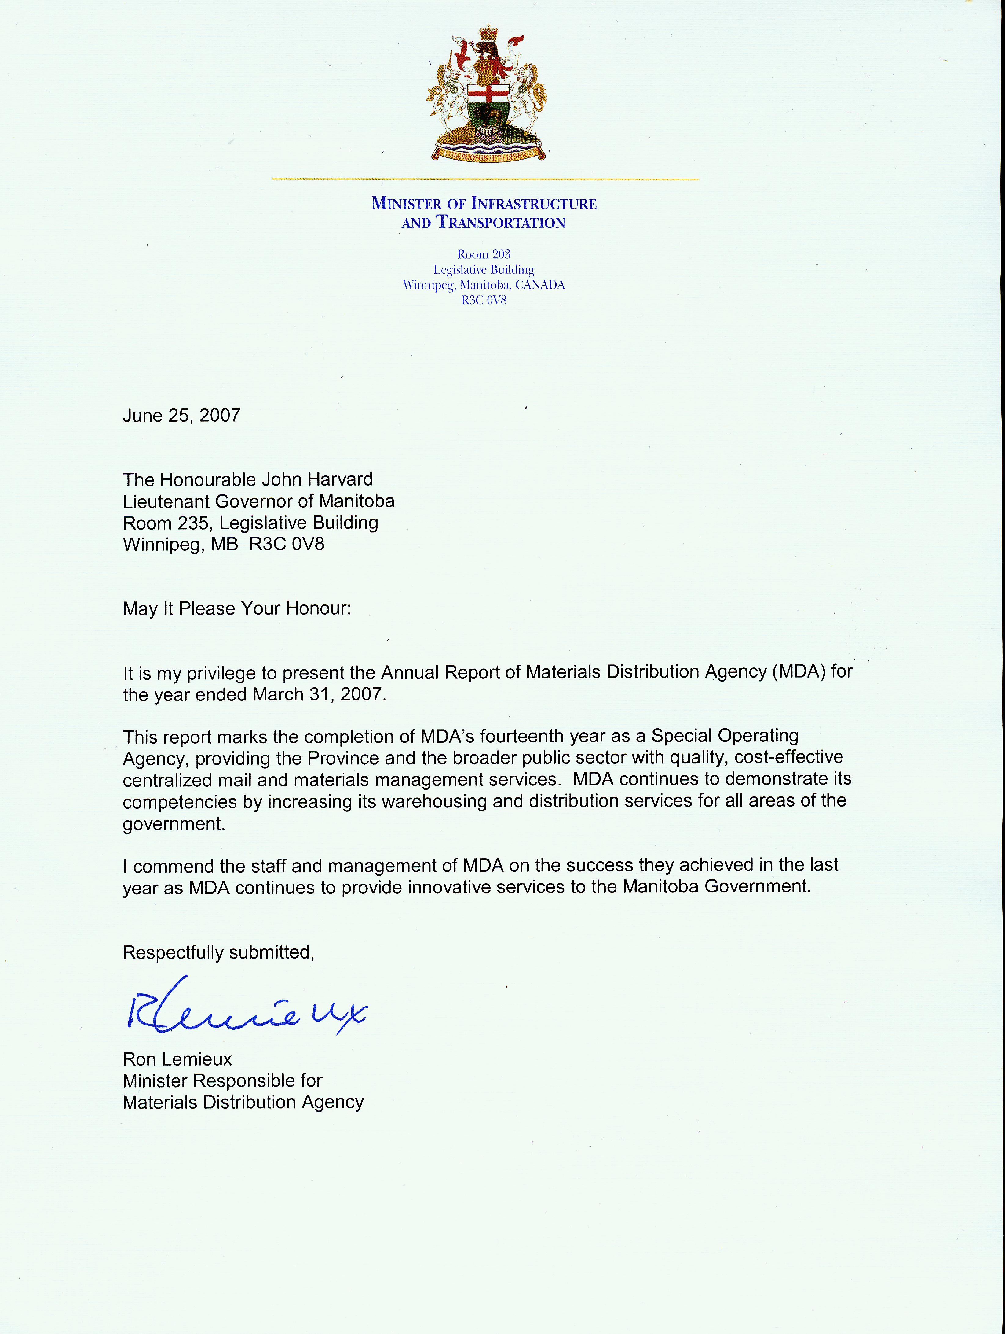
DEPUTY MINISTER’S LETTER OF TRANSMITTAL

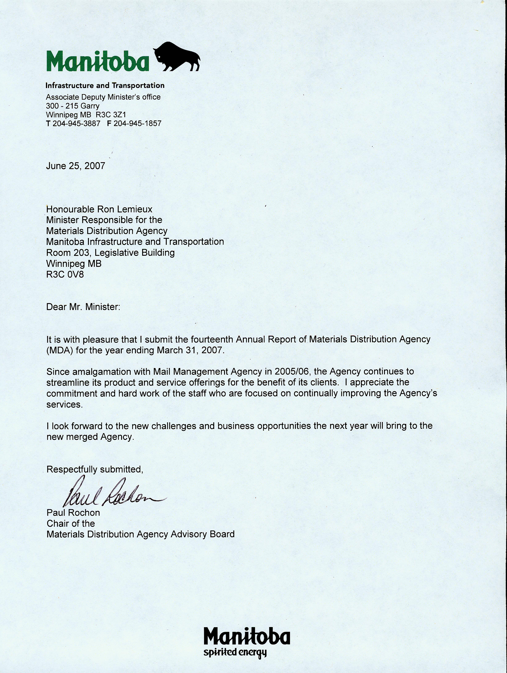

CHIEF OPERATING OFFICER’S LETTER OF TRANSMITTAL

June 27, 2008

To the many stakeholders of MDA:

I am honoured to present the Agency’s fifteenth Annual Report as a Special Operating Agency.

Materials Distribution Agency (MDA) has a vision to be the leader in distribution services for the Provincial Government. To save client’s resources and time, MDA must be prompt, competitively priced and reliable. MDA fosters an atmosphere of continuous improvement to offer clients the services they require in the most efficient manner.

The Agency is proud of its ability to save government client’s time and money by offering a cost effective one-stop-shop for goods and services. Clients such as Employment and Income Assistance Program, Manitoba Textbook Bureau, and Manitoba Health have realized costs savings and time efficiencies through the use of MDA for their distribution of goods.

I would like to thank all clients for their continued support of MDA. When they ask MDA to take on their distribution projects, it is an endorsement of the Agency’s vision and commitment to service excellence. MDA strives to exceed client expectations.

Sincerely,



Dave Bishop
Chief Operating Officer - MDA

BACKGROUND

The Government of Manitoba has seventeen Special Operating Agencies (SOA’s) under the Special Operating Agencies Financing Authority Act. In Manitoba, SOA’s are an operational organization within a Government department. The Charter and the Schedule of Delegated Authorities define the Agency’s accountability relationships. These framework documents lay out target commitments for service levels and financial performance.

The SOA concept reflects government’s desire to support improved service to clients; increased latitude for innovation; empowerment of staff; better management of people; and clearly defined accountability for results. Agencies have more direct responsibility for results and additional flexibility regarding staffing, capital investments, rate setting, financial systems and accounting procedures.

Every year, SOA’s must prepare a business plan that provides a blueprint for the activities, revenues and expenditures for the upcoming year. Once approved, the Agency provides quarterly and yearly reports on progress against those goals.

Materials Distribution was created in 1974, to provide the government with centralized materials management for government departments, boards, commissions and agencies and became a Special Operating Agency in 1993. Postal Services was created in 1954 to provide government wide postal services and it became an SOA in 1996. The organizations amalgamated April 1, 2005. The Agency’s mandate is to cost effectively meet the mail and material distribution requirements of organizations within the broader public service.

STRUCTURE FOR OPERATIONS

Accountability Structure

As an organization within Manitoba Infrastructure and Transportation, MDA reports directly to the Assistant Deputy Minister, Supply and Services, and is held accountable to the Associate Deputy Minister, Deputy Minister, and Minister of Infrastructure and Transportation for operational and financial performance.

The Agency operates outside of the Consolidated Fund under the Special Operating Agencies Financing Authority (SOAFA), which holds title to the Agency’s assets, provides financing for operations, and is responsible for its liabilities. Governance and accountability are substantiated by MDA’s compliance with its Operating Charter, Transfer Agreement, Management Agreement, applicable General Manual of Administration policies, and by The Special Operating Agencies Financing Authority Act. Financial and operational information and requirements are disseminated to and from Treasury Board through a SOA Coordinator at Treasury Board Secretariat.

The Accountability Structure Chart presented below outlines the current structure:

Legislative Assembly
Materials Distribution
Agency
Accountability Structure Chart
March 31, 2008

Cabinet

Minister of Infrastructure and Transportation

Treasury Board

Deputy Minister of Infrastructure and Transportation

Minister of Finance

Associate Deputy Minister of Infrastructure and Transportation

Special Operating Agencies Financing Authority

Advisory Board
Assistant Deputy Minister Supply and Services

Chief Operating Officer
Materials Distribution Agency

Advisory Board

The Advisory Board for Materials Distribution Agency meets as required to review the Agency’s financial and operating reports, the draft Business Plan, and any proposed changes to the Agency’s Charter. The Board’s members offer advice and direction on reporting and management issues of concern, and on short and long term strategic planning.

Members of the MDA Advisory Board as of March 31, 2008, are listed below.

Members of the Advisory Board for Materials Distribution Agency

CHAIR Paul Rochon
Associate Deputy Minister
Manitoba Infrastructure and Transportation

MEMBERS

Private Sector Position vacant
Representative

Client Fred Meier Kim Sharman
Representatives Assistant Deputy Minister Assistant Deputy Minister
Manitoba Conservation Manitoba Health and Healthy Living

Ex Officio Tracey Danowski David Bishop
Assistant Deputy Minister Chief Operating Officer Supply and Services Division Materials Distribution Agency
Manitoba Infrastructure and Transportation

Staff Representative Robert Nicholls
A/Logistics Manager
Materials Distribution Agency

MDA MISSION STATEMENT

Mission

This Agency provides mail and material management services to the public sector.

ORGANIZATIONAL GOALS

Employees – To increase employee job satisfaction and foster a respectful workplace.

Service – To sustain and improve customer service by developing infrastructure, setting standards and meeting or exceeding customer needs.

Growth – To grow business while maintaining or decreasing overall government expenditures.

ORGANIZATIONAL VALUES

The Agency supports its mission statements and goals with its operating values.

Reliability
MDA:
- Continually improves all aspects of its organization
- Provides consistent services
- Establishes and follows standards
- Does not make promises it can’t keep
- Meets deadlines
- Is fair
- Demonstrates integrity

Teamwork
MDA:
- Behaves ethically
- Recognizes achievements
- Communicates
- Is positive
- Sees each call as an opportunity
- Values diversity of backgrounds and opinions
- Creates and supports a common direction and common goals
- Demonstrates the priority of team goals

Accountability
MDA:
- Meets deadlines
- Provides clients with quality assured goods
- Saves government clients money
- Strives to know its clients’ needs

AGENCY PRODUCTS

MDA bulk purchases a variety of commonly used supplies and distributes these goods in smaller quantities as needed by its clients. These distinct product lines are listed below:

Commodities | Line Items
Stationery and Office Supplies | 933
Janitorial Supplies | 306
Medical Supplies | 916
Home Care Equipment | 164
Office Furnishings and Furniture | 113
Brochures | 131
Total Line Items | 2,563

AGENCY SERVICES

MDA provides the following lines of business and key services:

Mail Processing
MDA processes different types of mail for clients. MDA weighs and ascertains postage of standard and oversized mail through high-speed mail machines. Staff affixes appropriate postage to letter mail that exceeds the maximum dimensions or weight through two computerized shipping systems, high volume mail through permit mail using pre-printed indicia on envelopes and prepaid mailings through use of numerically controlled Canada Post envelopes. The current cost to clients is made up of actual postage and a separate processing fee which varies depending on type (i.e. metered, permit etc.). MDA has other products such as variable rate services including Business Reply Mail, Returned Mail, and Short Paid Mail.

Mail Finishing
MDA provides clients with various types of Mail Finishing Services such as envelope addressing, bursting of printed forms and cheques, folding of printed material, inserting into envelopes and manual collating of items into kits or envelopes.

Interdepartmental Mail
Clients purchase Prepaid Labels in four denominations (Letter, Oversize Letter, Small Packet, and Parcel). MDA also offers Signature Service, which provides clients with confirmation of delivery of mail.

Contract Administration
MDA offers the broader public sector access to its volume based contracted courier and parcel rates.

Digital Printing
MDA’s Variable Data Print Service provides clients with “just-in-time” printing of electronic documents on high-speed digital black and white printers that can be immediately transferred to the Finishing, Processing, and Interdepartmental lines of business.

Home Care Equipment Rental
MDA provides a comprehensive Rental, Repair and Service Program. MDA receives and repairs any damaged or non-functioning component and disinfects the item before returning it to the active equipment rental pool. MDA carries out periodic safety checks on equipment in the field to ensure it is in good working condition. This program continues to grow, which is consistent with the demographics and growing reliance on Home Care solutions. MDA expects to see significant growth in the Employment and Income Assistance Program (EIA). MDA is tracking EIA and Child Special Services Program equipment use. EIA has asked MDA to implement an electronic solution for tracking of equipment.

Office Equipment Service and Rental
Desktop computers have reduced the need for the Office Equipment Service Program and rental. Revenue for this line is gradually diminishing. MDA will provide this service until market demand significantly declines.

Key Copy Centres
MDA administers the Copy Centre Program and orders, ensures delivery of supplies to each copy centre and arranges for repairs and maintenance. As contracts are renewed or mature, Procurement Services Branch (PSB) of Manitoba Infrastructure and Transportation assesses the appropriateness of copy centre services and may replace manual keys with electronic keys. This service is expected to grow at a slow rate and is dependent on the corporate wide goals for copy centres.

Warehouse and Distribution Services
MDA provides Warehouse and Distribution Services to other agencies and departments, which includes picking and packing for provincial, national and international distribution.

Transportation, Storage and Disposal Services
MDA provides moving services resulting in significant cost savings for which it consistently receives positive client feedback. Secure storage facilities are also provided. MDA also disposes of goods and furnishings government offices no longer need. Often MDA reassigns these items to other agencies that have short-term needs. MDA disposes non-recyclable items through auction, tendered and un-tendered sales and through recycling companies.

MARKET SEGMENT INFORMATION

Total Revenue 2007/08 $22,906,000

Revenue by Market Segment
Federal
Government
1%
Provincial
Government
Departments
70%
Boards,
Commissions,
Agencies
3%
Regional Health
Authorities
26%

WAREHOUSE PRODUCTS – DISTRIBUTION INFORMATION

Number of Orders | 2007/08 | 2006/07 | 2005/06
MDA Orders | 55,585 | 51,045 | 55,752
Manitoba Textbook Orders | 12,584 | 15,892 | 17,428

Location Distribution of Warehoused Products | 2007/08 | 2006/07 | 2005/06
Winnipeg | 60% | 54% | 55%
Rural | 40% | 46% | 45%

Delivery Distribution of Winnipeg Orders | 2007/08 | 2006/07 | 2005/06
Regular (2 days) | 91% | 93% | 92%
Same day | 3% | 4% | 2%
Pickup | 6% | 3% | 6%

2007/08 PROJECTS AND ACTIVITY STATUS HIGHLIGHTS

- Human Resources Overview

Goal: To enhance understanding of Diversity, improve staff attendance and to improve staff health assessments rates by introducing staff well being strategies
Update on strategy
- Ensure all staff attend Diversity Workshop | - 50 staff attended in 2006/07, 20 staff attended in 1st quarter, and 10 are registered for June 2008
- Continue the voluntary light exercise program | - 22 staff participated in the pedometer challenge logging over 10 million steps
- Host a Wellness Fair by June 30, 2007 | - The first ever MDA Wellness Fair was held in April 2007 with over 100 staff, family members and other civil servants in attendance. There were 15 sessions with representatives from 10 health agencies. The Minister of Healthy Living, the Honourable Kerri Irvin-Ross spoke at the closing ceremonies. This has now become a yearly event

Goal: To have effective plans to identify and train leaders for tomorrow
Update on strategy
- Have each manager develop a learning plan by September 1, 2007 | - Each manager has a learning plan developed which will be updated with “Learning Policy” information from the Civil Service Commission

Goal: To address Agency-wide training needs
Update on strategies
- Introduce a comprehensive Customer Focused Training Program for staff who deal with clients, by September 2007 | - Ongoing

- Logistics Overview

Goal: To provide leadership training to enhance management potential of employees by offering specific training tools to staff
Update on strategies
- Incorporate, on an annual basis, performance management appraisals for all staff by December 2008 | - New term staff had performance evaluations completed as required
- Assist in MDA's Wellness Plan by encouraging employees to participate by March 2008 | - Increased participation by 70%
- Continue core competency training for all warehouse positions | - Ongoing with team leads
- Review and increase security levels for the entire facility by December 2007 | - Review completed and 4 improvements made with 3 more in process
Goal: To enhance workflow, client service requirements and maximize productivity and accuracy while sourcing hidden costs to control expenditures
Update on strategies
- Review the Logistic area organization structure and present recommendations to the Management Committee by September 1, 2007 | - Completed
- Review current business growth and new business requirements and their impact on warehouse space by October 31, 2007 | - Completed
- Expand the Quality Control Program to other warehouse areas by September 2007 | - Quality Control has been expanded into the Jan/Stat area and is ongoing in all areas in the warehouse

Goal: To amalgamate Canada Post and Purolator shipping systems
Update on strategies
- Review shipping system requirements by December 31,2007 | - Completed
Goal: To analyze and determine best option for all Federal Mail functions and review overall processing area for potential space enhancements
Update on strategies
- Determine the benefits of purchasing new mail machines vs. leasing vs. outsourcing by June 30, 2007 | - Completed and hardware purchased
- Review satellite operations to determine expansion of services by June 2007 | - No expansion at this time. 405 Broadway to be closed in the fall of 2008

Goal: The Agency will prepare a plan to identify critical services lines and the response to major challenges
Update on strategies
- Work with the division team to develop a plan for continuation of critical client services, by December 2008 | - Draft Business Continuity Plan for MDA completed in March 2008. Final document will be finished in 2008/09 1st quarter
- Marketing and Sales Overview

Goal: To increase contact with clients
Update on strategies
- Implement planned client relationship strategies for key client groups | - Ongoing

Goal: To continue annual product reviews, introduce two product management Standard Operating Procedures (SOP’s) and identify at least ten new products per month
Update on strategies
- With Procurement Services Branch, review slow moving products every quarter | - Performed quarterly in collaboration with MDA’s Purchasing area
- Use product review groups to evaluate new and existing products and ensure products are evaluated every quarter | - Performed quarterly in collaboration with MDA’s Purchasing area

Goal: To implement more aggressive and frequent communication tools that dispel myths about: Service Delivery, Price and Product Quality and Availability
Update on strategies
- Publish Medical Product Catalogue focusing on differentiating medical products by program type in September 2007 | - Launch completed. Distribution took place February 2008
- Publish new Medical Updates Flyer each quarter | - Quarterly updates completed and are ongoing
- Continue cost recovery efforts for the catalogue | - Completed. Six ads placed
- Develop a brochure and folder kit of all Agency services by June 2007 | - Completed in September 2007
- Participate in at least three tradeshows including Manitoba Health Travel and Immunization Conference in April and Provincial Health Care Conference in September | - Attended Immunization Conference and Building Managers Conference and Association of Manitoba Municipalities Conference in November
- Coordinate product promotion events at government locations | - Completed. Nine product promotion events took place in Winnipeg and ten in Rural Manitoba

Goal: To develop service oriented staff that is technically competent in all marketing activities
Update on strategies
- Implement learning plans for each employee in Marketing by September 2007 | - Learning plan exercise initiated for all marketing staff
- Assist Logistics Manager in development of MDA orientation manual by March 31, 2008 | - Completed September 2007. Manual was expanded to include MIT’s orientation package

- Client Services Overview

Goal: To review the impact of “SAP First” policy on MDA’s workload
Update on strategies
- Monitor CSR transactions on a daily basis in the first two quarters to analyze impact on workloads due to “SAP First” policy | - Transactions monitored and increased by 6% which management determined did not require an increase in staffing
Goal: To have process direction and operational standards for furniture and drop shipments
Update on strategies
- Review existing processes for MDA’s furniture and drop shipments and update Operating Manuals by June 30, 2007 | - Completed in September 2007

Goal: To have accurate and current client rentals records
Update on strategies
- Issue yearly possession verification letters to all registered equipment clients by March 31, 2008 | - Completed - IT incorporated additional fields in letters to improve communication
- Develop a monthly process to issue Estate and Out-of-Province letters by April 15, 2007 | - Completed Estate section letters in November 2008. Out-of-Province process completed in January 2008

Goal: To meet Treasury Board’s direction by implementing an equipment-recycling program for client (EIA)
Update on strategies
- Establish a committee and liaison protocol with EIA by May 31, 2007 | - Completed

Goal: To review existing medical equipment on the Provincial Home Care Equipment Program
Update on strategies
- Review service and maintenance standards and develop a review process by January 31, 2008 | - SOP completed and monitoring mechanism is in place

Goal: To track and manage equipment maintenance and service requirements
Update on strategies
- Track service hours on new medical equipment programs by September 30, 2007 | - New program statistics are tracked and recorded
- Review staff levels to meet the growing workloads in Customer Service and Technician areas | - 23% workload increase in Technician area from fiscal year 2006/07

- Contracts and Purchasing Overview

Goal: To liaise with vendors, contract owners, and Procurement Services Branch (PSB) to establish and manage contracts that best meet the needs of the Agency and its clients
Update on strategies
- Identify opportunities and changes to tender specifications beneficial to the Agency and its clients | - MDA has established and made appropriate changes to specifications of contracts
- Review current tender templates and specifications and provide recommended changes to PSB | - Completed
- Implement a process to deal with vendor issues which create a disruption to service by June 30, 2007 | - Completed

Goal: To reduce the number of backorders and their associated costs
Update on strategies
- Monitor backorders to maintain a line item industry standard of 1.5% or less for the medical, stationery and janitorial items | - 2007/08 backorder rate was 1.5%
- Finalize the SOP to manage backorder situations by June 30, 2007 | - Completed

Goal: To reduce the number of redundant stocked items, making room for new products
Update on strategies
- Review minimal sales items and develop a discontinued item list, every quarter | - Completed
- Develop a Discontinued Products SOP by June 30, 2007 | - Completed
Goal: To improve established business relationships
Update on strategies
- Update all standardized letters to reflect a more customer service oriented approach by March 31, 2008 | - Changes have incorporated the new Provincial logo
Goal: To increase knowledge and understanding of the procurement process
Update on strategies
- Have MDA attendance at a Green Conference | - Attended two green janitorial presentations
- Have MDA attendance at the Canadian Forum on Public Procurement in September 2007 | - Manager attended conference

- Finance and Information Technology Overview

Goal: To provide on-going user, client and system support on a day-to-day basis to ensure technology goals are met
Update on strategies
- Initiate a life cycle management plan for both custom hardware and software to ensure migration paths are factored into annual budget planning by December 2007 | - Plans have been developed and monitored are being monitored

Goal: To review the Mail Services Billing System (Hermes)
Update on strategies
- Review the billing process to be completed by June 30, 2007 | - Review completed in June 2007. Printing and finishing processes to be removed from Hermes computer program by July 2008. Lock box fees and daily service revenue removed in February 2008. Processes will be set up so data is entered directly into Great Plains

Goal: To manage all aspects of SOA reporting and documents required by Treasury Board
Update on strategies
- File all reports and plans by dates required by Treasury Board | - All quarterly reports and Annual Report filed on time

Wellness Update

MDA’s goal is to become a healthy workplace, thus aligning with the province’s priority to promote healthy living. MDA recognizes the substantial savings to the Agency and health care system in the future that can be realized when people remain healthy longer. In addition, productivity increases with healthier workers.

MDA is constantly looking for ways to make the workplace better and to become a workplace of choice for future civil servants.

The MDA Wellness Coordinator is a member of the Provincial Workplace Wellness Alliance which allows networking with other organizations who also view employee wellness as critical to the success of their organizations.

During 2007/08 MDA held several wellness events:

- A speaker from Seven Oaks Wellness Institute spoke to 30 staff on proper lifting techniques.
- A speaker presented to all staff on working positively in the workplace.
- Two healthy lunches were provided to MDA staff.
- MDA held its second annual Wellness Fair attracting over 80 people including the Minister of Healthy Living.
- Approximately 22 MDA staff participated in the first pedometer challenge.

FINANCIAL OVERVIEW

Review of Operations
MDA has seen the volume and breadth of products grow in most commodity lines. Current clients are ordering more of products commonly stocked, while also requesting that MDA expand its lines of goods. As their needs change, clients look to MDA to assume warehousing and distributing at a lower cost.

The following financial review and analysis compares the actual results for the year ended March 31, 2008 to the projections for the same period and to the actual results for the year ended March 31, 2007.

MDA reported net income of $83,000 before revenue sharing for the year ended March 31, 2008 compared to a projected loss of $47,000 for 2008 and actual loss of $174,000 for the year ended March 31, 2007.

 | 2008  Actual | 2008  Projected | 2008 Actual vs. Projected  Increase (Decrease) | 2007  Actual | 2008 Actual  vs. 2007 Actual  Increase (Decrease)
Warehouse Sales  Cost of goods sold | 12,517  9,961 | 11,050  8,840 | 1,467  1,121 | 11,999  9,677 | 518  284
Gross profit | 2,556 | 2,210 | 346 | 2,322 | 234
Service Revenue  Total Revenue  Expenses  Salaries & benefits  Occupancy costs  Administrative | 10,389  12,945  4,186  724  7,952 | 9,415  11,625  3,960  780  6,932 | 974  1,320  226  (56)  1,020 | 9,970  12,292  3,940  785  7,741 | 419  653  246  (61)  209
Total Expenses | 12,862 | 11,672 | 1,190 | 12,466 | 396
Net income/(loss) | 83 | (47) | 130 | (174) | 257
Retained Earnings | 2,671 | 2,496 | 175 | 2,988 | (317)
Revenue Sharing | 400 | 400 | -- | 400 | --

Financial Position
The Agency did not use its working capital payable line of credit at any time during this fiscal year. The Agency has no working capital payable outstanding.

Remaining cash generated by operations was used to purchase capital and other assets and to pay revenue sharing amounts to the Consolidated Fund ($400).

Ratio Analysis

Ratio | 2008 | 2007 | 2006 | 2005
Return on total revenue | .64% | -.79% | − .002 % | .003%
Return on average assets | 1.08% | -2.21% | .003% | .006%
Gross profit percentage | 20.40% | 19.35% | 19.00% | 17.80%
Debt to equity | .48 to 1 | .44 to 1 | .39 to 1 | .45 to 1
Current ratio | 1.62 to 1 | 1.74 to 1 | 1.81 to 1 | 1.73 to 1
Days sales in receivables | 46 days | 49 days | 48 days | 67 days
Inventory turnover | 6.63 times | 6.54 times | 6.16 times | 5.99 times

Performance Measures

 | 2008 | 2007 | 2006 | 2005
Turn Around Time (within MDA):  Health Orders – Urban  Health Orders – Rural  Other Goods – Urban  Other Goods – Rural  MB Textbook Bureau | 1  2  1  2  2 | 1  2  2  2  3 | 1  2  1  2  3 | 1  2  1  2  3
No. Sales Invoices | 56,557 | 53,643 | 62,216 | 89,404
No. Inventory Items | 2,563 | 4,123 | 4,149 | 4,628

